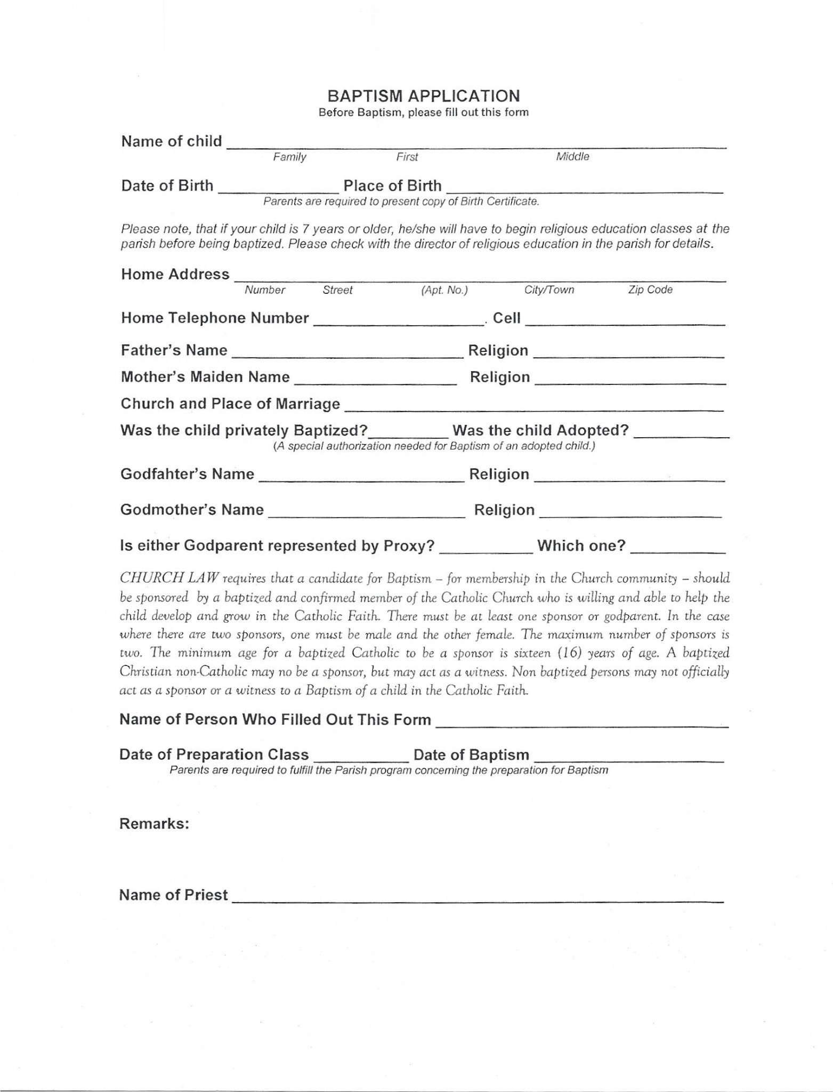
SAINT AUGUSTINE CHURCH

